Home Assignment 1

Designing and creating a basic 2D game

Question 1a:

Two popular game engines are Unity and Unreal engine.

* Unity engine makes use of C# to code.
* Unity is totally free compared to Unreal Engine.
* Available for almost every platform.
* Has an Asset store.

Question 1b:

Two programming languages that are used for game development are C# and C++.

* C# doesn’t need any special configurations to integrate with Windows.
* Due to its popularity it’s easy to find other C# developers to make use of for business reasons or to get code snippets for projects.
* It has a vast number of libraries that help the programmer to code.
* C# is properly management which helps the user to not worry about memory management and focus on the programming.

Question 2a:

Loops until all goals are scored

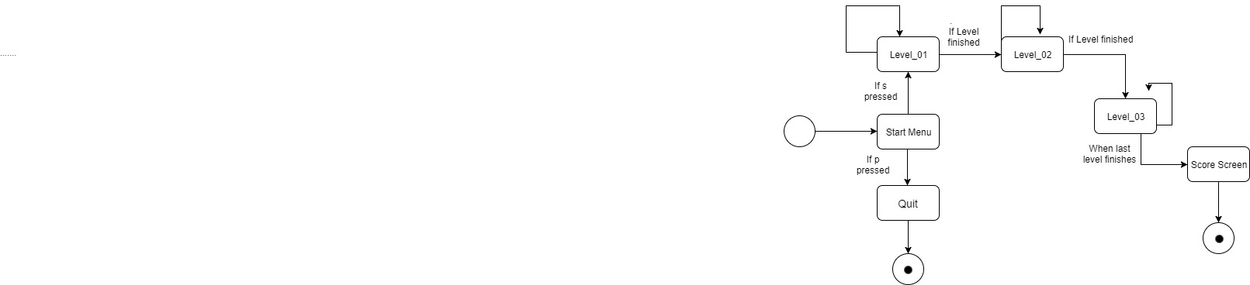

Loops until all goals are scored

Loops until all goals are scored

Question 2b:

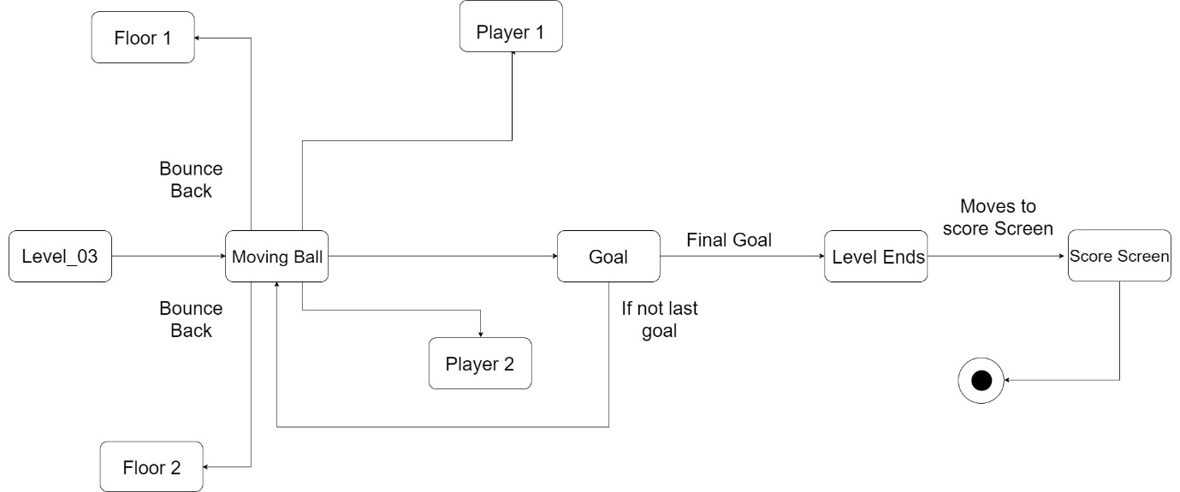

A goal is scored

Game Playing

Game Playing

Bounces Back

Level Starts

Bounces Back

Question 3:

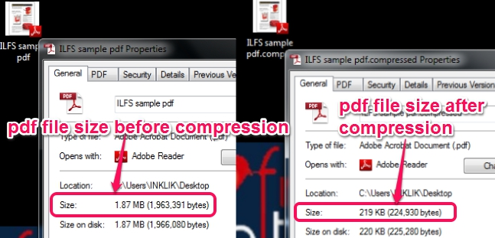

Data Compression involves the process of encoding the same information (in this case assets) using fewer bits than the primary version (Wikipedia). Compression is important and needed in media assets because transfer speeds will reduce due to less file sizes. Another plus of using compression in media assets is the program speed when requesting connection with the network. Something else that helps is obviously when it comes to downloading and uploading of files which contain these assets, for example when downloading/uploading to/from an app store. They will download/upload faster and will take far less storage space then.

# *References*

Ball, K. (2016, March 3). *What are the pros and cons of learning C# as a first programming language?* Retrieved from Quora: https://www.quora.com/What-are-the-pros-and-cons-of-learning-C-as-a-first-programming-language

*C++ performance vs. Java/C#*. (2008, October). Retrieved from Stack Overflow: https://stackoverflow.com/questions/145110/c-performance-vs-java-c

Lysis. (2017). *Pros and Cons of Using C# as Your Backend Programming Language* . Retrieved from Agilities: https://agilites.com/pros-and-cons-of-using-c-as-your-backend-programming-language.html

Prinke, M. (2016, November 5). *What are the pros and cons of Unity?* Retrieved from Quora: https://www.quora.com/What-are-the-pros-and-cons-of-Unity

Super, D. (2016, March 27). *What are the main pros and cons of Unity 3D and Unreal Engine?* Retrieved from Quora: https://www.quora.com/What-are-the-main-pros-and-cons-of-Unity-3D-and-Unreal-Engine

Timmer, Y. (2017, November 22). *Is C# really slower than say C++?* Retrieved from Stack overflow: Is C# really slower than say C++?

*Unreal Engine Forums*. (2004-2017). Retrieved from Unreal Engine: https://forums.unrealengine.com/community/general-discussion/92051-is-unreal-engine-4-completely-free